**Rossmoyne Senior High School Physics Unit 3 and 4 2021**

**Period Zero Test 3: Wave Particle Duality and the Quantum Theory**

**Name: __________________________________ Score: _________ /50**

**Time:** 45 min + 5 min reading

**Materials Provided:** This Question/Answer Booklet and the Formulae and Data Booklet

**Instructions:** When calculating numerical answers, show your working or reasoning clearly and include appropriate units. Give final answers to **three** significant figures. When estimating numerical answers, give final answers to a maximum of **two** significant figures.

1. Radar is used as a detection system through the production and detection of radio waves.
   1. A transmitter is a conductor of electrons that is used to produce the radio waves that propagate through the air. Describe how the transmitter is able to produce radio waves. [2 marks]

The transmitter will oscillate the electrons with an alternating emf. 1

An oscillating/accelerating electric charge produces electromagnetic waves. 1

* 1. The radio waves produced have a 15.0 × 102 MHz frequency. Calculate the wavelength of the radio wave. [2 marks]

$λ=\frac{c}{f}=\frac{3.00*{10}^{8}}{15.0*{10}^{8}}=0.200 m$

1 for conversion of MHz

1 for application of formula

* 1. Describe the behaviour of electrons in the receiving antenna when interacting with the radio waves. [1 mark]

Electromagnetic radiation will oscillate the charged particles in the antenna. 1

* 1. Describe why the receiving antenna being surrounded by a curved dish helps with the detection of the radio waves. [2 marks]

The curved dish will reflect radio waves towards the antenna 1

This increases the intensity/amplitude of the wave/signal making it easier to detect 1

1. The diagram shows a beam of **polarised** light being directed through a polariser into a photosensitive material behind. The photosensitive material records the intensity of the light reaching it.

Photosensitive material

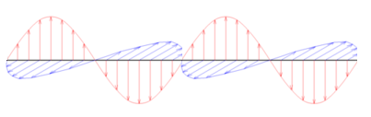

Light beam

Polariser

* 1. Describe what polarised light is. [1 mark]

Light which has its electric (or magnetic) field oscillating within a single orientation/plane. 1

* 1. The photosensitive material detects high intensity in the current arrangement shown in the diagram. The polariser is slowly rotated 1800 around an axis in line with the light’s velocity (as shown by curved arrow). Describe how the intensity of the light, as measured by the photosensitive material is affected during the rotation, if at all. [2 marks]

The intensity will transition from high to zero and back to high.

2 if intensity returns back to high

1 ONLY if transition is from high to zero only

* 1. Does the polarisation phenomena provide evidence light is a transverse or longitudinal wave? Describe how it supports one of these wave types but eliminates the other type. [3 marks]

Transverse 1

A transverse wave oscillates perpendicular to its velocity allowing for the oscillations to occur in different planes/alignments 1 for supporting evidence

Longitudinal waves oscillate along the velocity of the wave so it has no means to have different oscillation planes/alignments 1 for refuting evidence

1. Stars are incredibly hot and dense astronomical bodies that emit all wavelengths of electromagnetic radiation (from radio waves to gamma waves). The spectra of a red star and a blue star equidistant from Earth are shown below.

Red star

* 1. By drawing a single arrow, and labelling it, identify which spectrum is for the red star. [1 mark]

Correctly labels curve 1

* 1. What physical property of stars, and black bodies in general, determines their colour? [1 mark]

Temperature

1

* 1. When the starlight is analysed by Earth based observatories, will an absorption or emission spectrum be viewed? Justify your choice. [2 marks]

Absorption 1

The light from the star passes through atmospheric gases (surrounding either Earth or the Sun will suffice) which absorb characteristic frequencies. 1

1. The threshold wavelength for selenium used in a photoelectric experiment is 2.43 × 10-7 m.
   1. Define the meaning of a threshold wavelength within the context of the photoelectric experiment. [2 marks]

The threshold wavelength is the **longest wavelength** incident light that can cause the **emission of photoelectrons.**

1 for ***longest/largest*** wavelength

1 for relating to emission of photoelectrons

* 1. Calculate the work function of selenium in electron volts. [4 marks]

$E_{k}=hf-W (where E_{k}=0 at threshold wavelength)$

Also $f=c/λ$ 1 for equation and setting $E_{k}=0$

$W=hf=\frac{hc}{λ}=\frac{6.63*{10}^{-34}*3.00*{10}^{8}}{2.43*{10}^{-7}}=8.185*{10}^{-19} J$ 1-2

$W_{in eV}=8.185*\frac{{10}^{-19}}{1.60*{10}^{-19}}=5.12 eV$ 1

1. The energy levels of an atom within the crystal matrix of a laser is shown below. This laser emits red light at a wavelength of 688 nm which is a product of one of the transitions as the electron falls from the n = 4 energy level.

n= $∞$

n= 6

n= 5

n= 4

n= 3

n= 2

n= 1

0 eV

-2.32 eV

-2.67 eV

-3.99 eV

-5.80 eV

-9.62 eV

-18.5 eV

* 1. What is the ionisation energy of this atom? [1 mark]

18.5 eV 1

* 1. On the diagram, draw in all possible transitions the electron may take as it returns to the ground state from the n = 4 energy level. [2 marks]

6 unique transitions drawn 2

-1 for each missing transition

* 1. Which transition is responsible for the emission of the red laser light? Use calculations to support your answer. [3 marks]

Find energy of red photon

$E=hf=\frac{hc}{λ}=\frac{6.63*{10}^{-34}*3.00*{10}^{8}}{688*{10}^{-9}}=2.891*{10}^{-19} J$ 1

Convert to eV

$E_{in eV}=\frac{2.891*{10}^{-19}}{1.60*{10}^{-19}}=1.81 eV$ 1

Energy difference from n=4 to n=3 matches the energy of the photon 1

* 1. Describe why an external energy source is required for the stimulated emission of the 688 nm laser light. [2 marks]

The atom electrons need to be in the n=4 state for emission of a red photon. 1

Energy source provides the energy for this excited state. 1

1. Rainbows reveal the true nature of white light. A collection of suspended water droplets in the air can have light incident upon them originating from the Sun. As the light moves from air to water it decreases its speed to 76.9% of its speed in air. The change in speed causes the light to change direction.

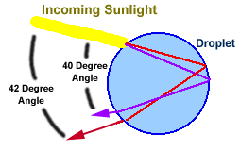

When the light reaches the back of the water droplet, it bounces off the boundary between water and air, returning to the front of the droplet. When the light leaves the front of the droplet, it changes speed and thus direction once more.

The trick to the formation of the rainbow is that each colour has its own unique speed in water. A different change in speed results in a different change in direction compared to other colours. Red is the fastest colour in water. It will have a different direction to violet, the slowest colour in water, after passing between the two mediums. This spreads the white light into all its colours.

* 1. Circle and clearly label one spot where refraction occurs in the diagram above.

[1 mark]

Clearly identifies where sunlight enters or leaves the droplet (1)

* 1. What is the name of the phenomena which causes white light to be separated into its component light? [1 mark]

Dispersion (1)

* 1. Determine both the frequency and wavelength of a 450 nm light wave once it has passed into water. [5 marks]

$f_{air}=\frac{c}{λ}=\frac{3.00×{10}^{8}}{450×{10}^{-9}}=6.667×{10}^{14} Hz$ (1-2)

$f_{water}=f_{air}=6.667×{10}^{14} Hz$ (or states f remains unchanged) (1)

$λ_{water}=\frac{v_{water}}{f_{water}}=\frac{0.769×3.00×{10}^{8}}{6.667×{10}^{14}}=3.46×{10}^{-7} m or 346 nm$ (1-2)

1. Light has a dual nature, seemingly able to behave as a wave under certain circumstances and as a particle under others.
2. State one experiment/situation where light is clearly behaving as a wave. [1 mark]

Double Slit Experiment/ Diffraction gratings (1)

1. Describe what the observations of this experiment/situation are and briefly explain how the observations support wave behaviour. [3 marks]

Monochromatic light shone through a pair of slits will show light and dark bands on a background screen. (Or similar, based on experiment choice 1)

The light must have undergone diffraction through the slits and interfered with itself on the screen, both being wave behaviours. (Or similar, based on experiment choice 1-2)

1. State one experiment/situation where light is clearly behaving as a particle. [1 mark]

Photoelectric effect/Compton scattering (1)

1. Describe what the observations of this experiment/situation are and briefly explain how the observations support particle behaviour. [3 marks]

A stream of photons, above some threshold frequency will cause the emission of photoelectrons from a target metal.

**OR**

Increasing the frequency of light incident on a target metal increases the kinetic energy of the photoelectrons.

**OR**

Increasing the brightness of the light incident on a target metal increases the number (but not energy) of photoelectrons emitted. (Or similar, based on experiment choice 1)

*Student clearly makes a connection between the stated observation and the particle nature of light, for example:*

“Below the threshold frequency, the photons do not have sufficient energy to remove an electron from the metal, no matter how long the light remains shining. This can be explained if the light is delivered in packets of energy, a particle behaviour. (Or similar, based on experiment choice 1-2)

1. Electrons are used in a double slit experiment, the setup and observations shown in the diagram below.

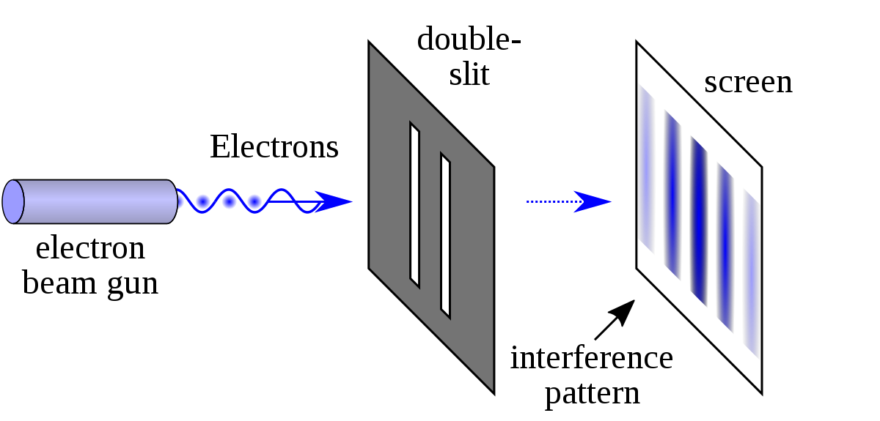

* 1. What does the interference pattern tell us about the nature of matter? [1 mark]

Matter exhibits wave characteristics 1

* 1. The electrons are fired from the electron beam gun at 3.86 × 105 m s-1. Calculate a suitable width of the slits to produce significant diffraction. [3 marks]

$λ=\frac{h}{mv}=\frac{6.63×{10}^{-34}}{9.11×{10}^{-31}×3.86×{10}^{5}}=1.89×{10}^{-9} m$ 1-2

The slit width should be similar to the wavelength, also 1.89×10-9 m 1

**END OF TEST**